# EXPLORE

## Problem Identification:

A school requires an interactive web application to integrate a vertical academic tutoring process. This will centralise and simplify the tutoring process to one website, granting younger students (Mentees) greater opportunity to find and book sessions with older students (Mentors) for the subjects they require assistance with. Mentors need to be able to easily select the weeks they are available each term and the subjects they are able to competently tutor as well as be able to view all of their open sessions that have been booked and to view feedback provided by mentees. Mentees need to be able to search for open sessions for the subjects they need assistance with and then be able to view their future sessions as well as be able to provide feedback to their mentors. Supervisors need to be able to see all feedback and generate reports on the grade/ subject session ratios. This web application will be developed using HTML and CSS whilst using PHP with MySQL to communicate with the relational database built in PHPMyAdmin. This application has a login system, allowing students to manage and view their sessions and bookings from home as well as at school.

## Assumptions:

* The platform will be developed through IPTOnline using MySQL and PHPMyAdmin.
* There is one tutoring session each week (Monday Period 6 in the Peer Support Lesson).
* Students are at an age where they are competent in using web applications/ the internet/ technology and understand what they are doing. (Or have a respective guardian that can assist.)
* All users have a school email.
* 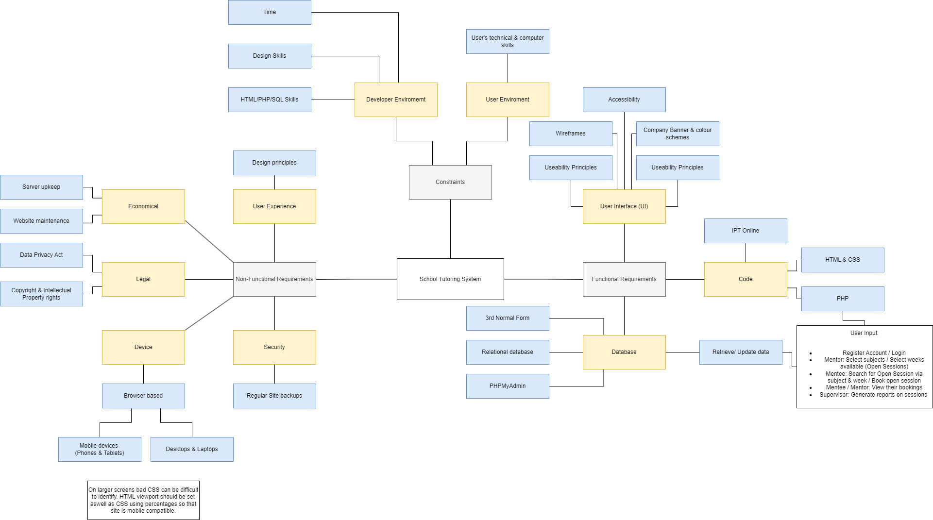Each tutoring session has only one mentor and one mentee.
* Students know/ remember which school week and term it is (EG: Term 4 Week 3).
* Both the mentors and mentees remember when and where the tutoring sessions are (and attend them).

## Criteria:

**Prescribed:**

By the due date, 8:30 am Monday 2nd October 2023:

* Designed and implemented an effective normalised relational database to store data and user inputs.
* Students can register as a mentee or mentor. (Supervisor accounts are preset to protect system safety and data integrity)
* Mentees can find tutoring sessions for their subject then book it and provide feedback.
* Mentors can select subjects to tutor and open sessions when they are available, and view provided feedback.
* Both Mentees and Mentors can view their future sessions
* Supervisors can view all open and booked sessions as well as reports for the number of sessions booked for subject/ year level combinations.
* Use consistent variables and file naming conventions.
* Have a learnable user interface (UI) that is effective and accessible while maintaining an enjoyable user experience (UX)

**Self-determined:**

By before the due date, on Friday 29th September 2023:

* (Ensure all prescribed criteria are met.)
* (Build a prototype login and register system that assists the criteria above.)
* Ensure all code is commented, indented, and appropriately used whitespace on all pages.
* Effectively use HTML and PHP to create a consistent website structure.
* Effectively use CSS to create a consistent website design and user experience UX.
* Appropriately use HTML and CSS to have a consistent and learnable UI and adhere to design principles.
* Use selection and iteration in PHP to produce efficient code.
* Implement measures to protect data integrity.
* Use PHP to interpret and display data retrieved from the SQL database.

## Database fields:

userID, fName, sName, email, tel (op), grade, password, lvlID, subjectID, subjectName, sessionID, menteeID, mentorID, year, term, week, booked, lvlID, lvlName

## Audience:

The users of this web application will be students who actively need tutoring and students who are able to tutor. As well as system administrators (Supervisors) who have higher system privileges. Assistance may be needed for younger students. A simple UI is implemented for easy learnability and to maintain accessibility.

## Mind Map

# Develop

## Data Flow Diagram (DFD)

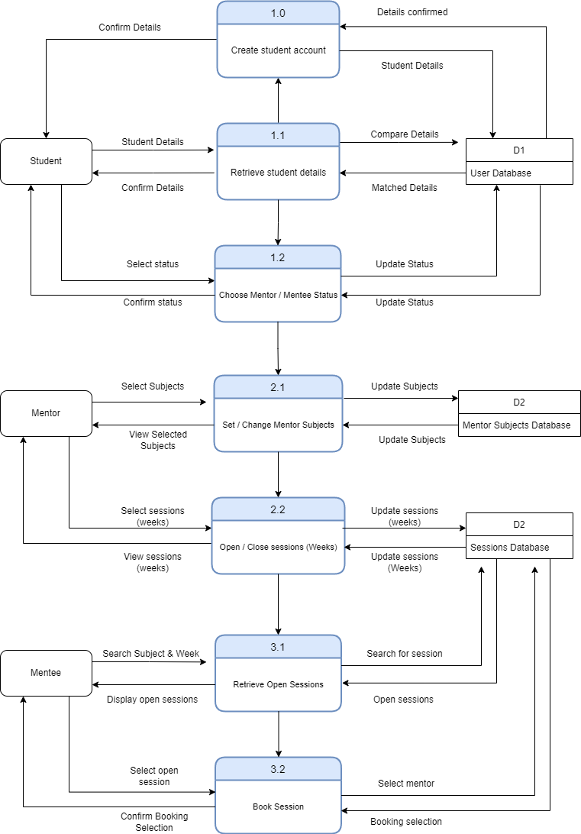Main Processes

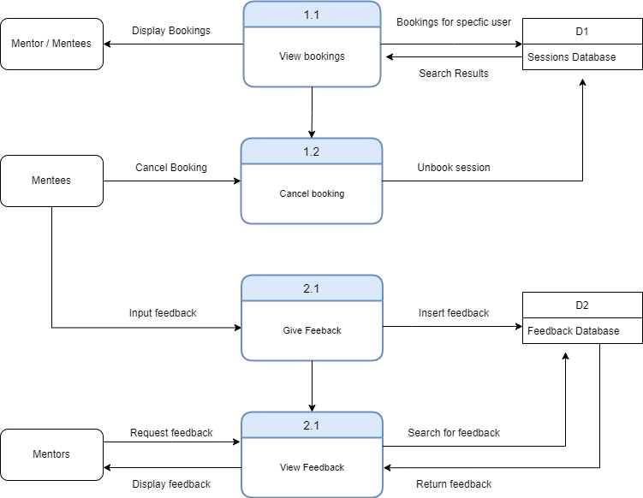Cancellation and feedback process

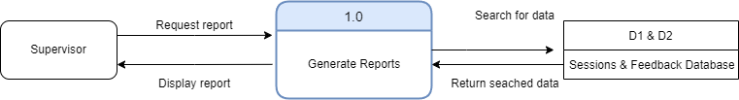Supervisor report process

## Entity Relationship Diagram (ERD)

An entity relationship diagram (ERD) is used to display the relationships between the separate entities within the database. ERDs display the logical connections within the structure of the database.

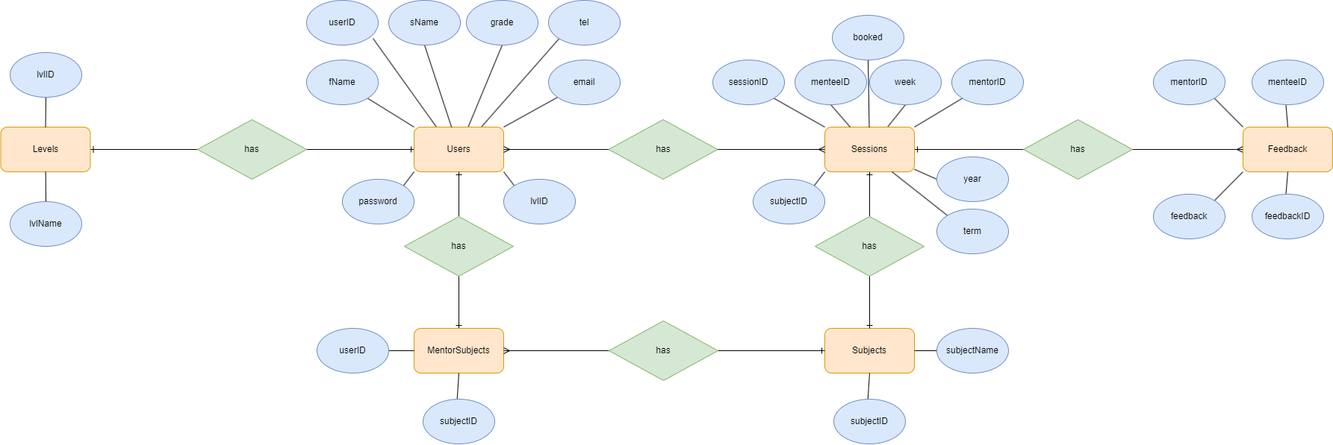

Many:1 Relationship

Many:Many Relationship

1:1 Relationship

## Relational Schema

A relational schema is used to display the direct foreign key to primary key connections between the columns of each table within the database. Column names that are bolded and underlined are primary keys, whilst the table with multiple bolded columns have composite keys.

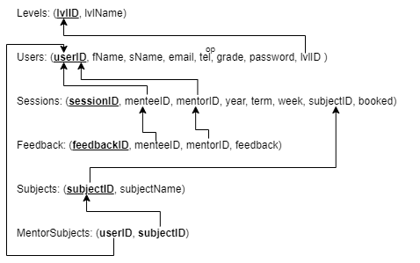

## Data Dictionary

Users

|  |  |  |  |
| --- | --- | --- | --- |
| FIELD | DATA TYPE | VALIDATION RULES | EXAMPLE DATA |
| userID | Int(5) | Primary key, AUTO_INCREMENT | 1 |
| fName | varchar(35) | NOT NULL | Riley |
| sName | varchar(35) | NOT NULL | Hampson |
| email | varchar(50) | NOT NULL | rhamp14@eq.edu.au |
| tel | int(10) |  | 04 1111 2222 |
| grade | int(2) | NOT NULL | 11 |
| password | varchar(35) | NOT NULL | Password |
| lvlID | int(1) | Foreign key,  NOT NULL | 1 |

Levels

|  |  |  |  |
| --- | --- | --- | --- |
| FIELD | DATA TYPE | VALIDATION RULES | EXAMPLE DATA |
| lvlID | int(1) | Primary key,  AUTO_INCREMENT | 1 |
| lvlName | varchar(25) | NOT NULL | Mentee |

MentorSubjects

|  |  |  |  |
| --- | --- | --- | --- |
| FIELD | DATA TYPE | VALIDATION RULES | EXAMPLE DATA |
| userID | int(5) | Foreign key,  NOT NULL | 1 |
| subjectID | int(2) | Foreign key,  NOT NULL | 1 |

Subjects

|  |  |  |  |
| --- | --- | --- | --- |
| FIELD | DATA TYPE | VALIDATION RULES | EXAMPLE DATA |
| subjectID | int(5) | Foreign key,  NOT NULL | 1 |
| subjectName | int(2) | Foreign key,  NOT NULL | Digital Solutions |

Sessions

|  |  |  |  |
| --- | --- | --- | --- |
| FIELD | DATA TYPE | VALIDATION RULES | EXAMPLE DATA |
| sessionID | int(5) | Primary key,  AUTO_INCREMENT | 5 |
| menteeID | int(5) | Foreign key | 1 |
| mentorID | int(5) | Foreign key,  NOT NULL | 5 |
| year | int(4) | NOT NULL | 2023 |
| term | int(1) | NOT NULL | 4 |
| week | int(2) | NOT NULL | 2 |
| subjectID | int(2) | Foreign key | 1 |
| booked | varchar(1) | NOT NULL | Y |

|  |  |  |  |
| --- | --- | --- | --- |
| FIELD | DATA TYPE | VALIDATION RULES | EXAMPLE DATA |
| feedbackID | int(5) | Primary key,  AUTO_INCREMENT | 5 |
| menteeID | int(5) | Foreign key | 1 |
| mentorID | int(5) | Foreign key,  NOT NULL | 5 |
| feedback | varchar(2000) | NOT NULL | You explained the topic great! Please continue doing as you do. |

## Sample Tables

Users

|  |  |  |  |  |  |  |  |
| --- | --- | --- | --- | --- | --- | --- | --- |
| userID | fName | sName | email | tel | grade | password | lvlID |
| 1 | Riley | Hampson | [rhamp14@eq.edu.au](mailto:rhamp14@eq.edu.au) | 04 1111 2222 | 11 | Password | 1 |
| 2 | John | Doe | [johndoe@mail.com](mailto:johndoe@mail.com) | 04 1234 5678 | 12 | !pA55w0Rd | 2 |
| 3 | Glen | Nixon | [gniox4@eq.edu.au](mailto:gniox4@eq.edu.au) | 04 8765 4321 | 0 | sir | 3 |

|  |  |
| --- | --- |
| subjectID | subjectName |
| 1 | Digital Solutions |
| 2 | Accounting |
| 3 | Chemistry |

Levels MentorSubjects Subjects

|  |  |
| --- | --- |
| lvlID | lvlName |
| 1 | Mentee |
| 2 | Mentor |
| 3 | Supervisor |

|  |  |
| --- | --- |
| userID | subjectID |
| 2 | 1 |
| 4 | 3 |
| 5 | 1 |

Sessions Feedback

|  |  |  |  |  |  |  |  |
| --- | --- | --- | --- | --- | --- | --- | --- |
| sessionID | menteeID | mentorID | year | term | week | subjectID | booked |
| 1 | 1 | 2 | 2023 | 4 | 1 | 2 | Y |
| 2 | 1 | 2 | 2023 | 4 | 2 | 2 | Y |
| 3 | 4 | 5 | 2023 | 4 | 5 | 1 | Y |
| 4 | *NULL* | 2 | 2023 | 4 | 3 | *NULL* | N |

|  |  |  |  |
| --- | --- | --- | --- |
| feedbackID | menteeID | mentorID | feedback |
| 1 | 1 | 2 | Good job! |
| 2 | 6 | 4 | You could try explaining the topics in a different way. |
| 3 | 7 | 5 | Amazing job |

## Normalisation

Normalisation is a decomposition system for databases that eliminates data redundancies and assists when inserting, deleting, and updating anomalies. A database that is normalised will reduce human error thus preserving data integrity across the system.

**First normal form (1NF)**

For this task, 1NF has been met. This is because all data has been verified atomic across all tables. The attribute values are singular and have been separated.

**Second normal form (2NF)**

Before moving to 2NF, 1NF must be compliant. For this task, 2NF has been met. For 2NF all non-key fields must be fully dependant on the designated primary key. Where it is practical, there are primary keys (Users = userID, Levels = lvlID, Sessions = sessionID, feedback= feedbackID, Subjects = subjectID) whilst for the MentorSubjects table there is a composite key because the two columns used will never produce duplicate results, rendering an extra column useless and wasteful.

**Third normal form (3NF)**

Before moving to 3NF, 2NF must be compliant. For this task, 3NF has been met. For 3NF it is further checking that all non-key fields are fully dependent on their respective primary key. It also recognises the practicality such as EG: not splitting the users into three different categories (mentee, mentor, supervisor) or splitting sessions into open and booked. EG: in Users it is easier to keep the value “1” instead of “Mentor” every time there is a mentor.

# User Interface

## Wireframes

The main homepage will contain a large prominent banner image containing the school institute along with the school’s name. Consequent form and action pages will have a dark grey banner with white text that matches the dynamic footer instead, whilst the nav section and article spaces will be lighter greys with dark text for contrast, assisting readability through design principles. The grey theme creates an easy formal mood, whilst being visually appealing.

Headings will be large and simple and should be mostly self-explanatory as to the purpose of the page. An appropriate amount of white space will be used to ensure the screen does not feel crowded and messy.

The header, footer and nav files will be separate files that are incorporated into the page using the “include ‘header.php’;” function. This limits repetition and allows for easy editing,

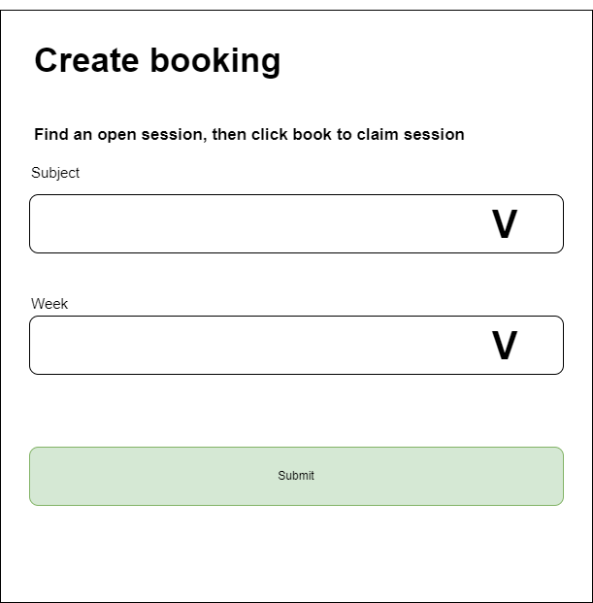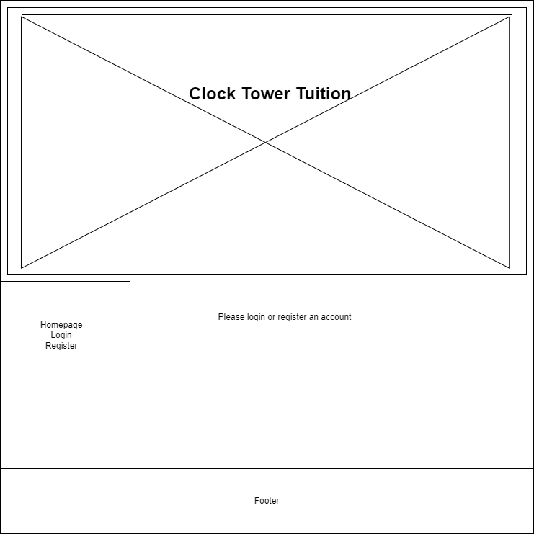

Drop-down menus are used along with php for ease of maintenance, meaning if a new subject is added, it doesn’t have to be manually added to the HTML form, instead it is automatically added due to the SQL. Drop-down menus are fixed, ensuring data integrity.

Placeholders are added as a guide to assist with data accuracy, reliability and again integrity.

Form attributes are also used, such as in the email, phone, and grade form. EG: An email must have a @ symbol, the phone number must be 8-10 digits and grade is limited from 1-12.

The banner will have ALT added for the visually impaired for accessibility.

Both the Nav links and homepage text are dynamic, changing when you login, changing with account types and when you start booking/ have booked sessions.

The footer is also dynamic, sitting at the bottom of the screen if the body section is smaller than the screen, and moves to the bottom of the page if the body section is larger than the screen.

## Form layouts

Forms will be comprised of textboxes and dropdown menus where appropriate and needed.

The buttons will consistently be green “Submit” buttons, placed below the form.

Labels and headings will have consistent alignment, sizing, and spacing.

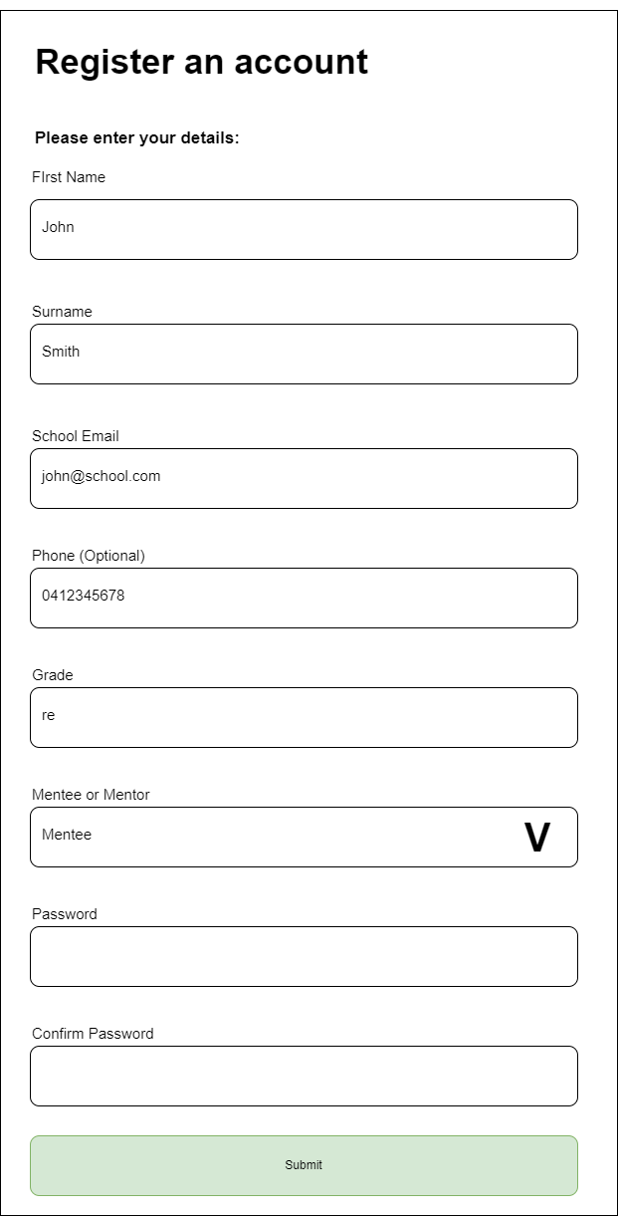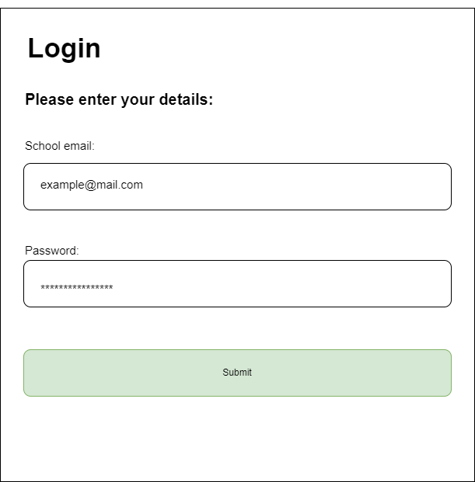

## Algorithm – Input, Process, Output Charts (IPO)

register.php viewBookings.php

|  |  |  |
| --- | --- | --- |
| Input | Process | Output |
| fName, sName, email, tel (op), grade, Mentee or Mentor, password | Algorithm to register account  **IF** submit has been pressed  **IF** password1 = password2  **SET** DbRequest TO  **INSERT INTO** Users  **EXECUTE** DbRequest storing results as Users  **FOR EACH** field of new owner details  **IF** field is valid  **SAVE** field in Users  **ELSE**  **OUTPUT** Error  **ENDIF**  **ENDFOR** | Confirmation or error message |

|  |  |  |
| --- | --- | --- |
| Input | Process | Output |
| userID | Algorithm to view booking for that user  **IF** var count > 0  **SET** DbRequest TO  **SELECT** s.sessionID, u.fName, u.sName, u.grade, u.email, su.subjectName, s.year, s.term, s.week  **FROM** Sessions s  **JOIN** Users u ON s.mentorID = u.userID  **JOIN** Subjectssu ON s.subjectID = su.subjectID  **WHERE s**.menteeID = '$userID'  **EXECUTE** DbRequest  **IF** inputs are valid  **OUTPUT** table of booked sessions  **ELSE**  **OUTPUT** “Go to create bookings to create bookings to claim a sesson!” | Table of booked sessions for that specific user |

Booking2.php

|  |  |  |
| --- | --- | --- |
| Input | Process | Output |
| subjectID, week | Algorithm to display free sessions so mentee can book them  **IF** post “Submit” isset  **SET** DbRequest TO  **SELECT** s.sessionID, u.fName, u.sName, u.email, subj.subjectName  **FROM** Sessions s  **INNER JOIN** Users u ON s.mentorID = u.userID  **INNER JOIN** MentorSubjects ms ON u.userID = ms.userID  **INNER JOIN** Subjects subj ON ms.subjectID = subj.subjectID  **WHERE** s.booked = 'N' AND subj.subjectID = Inputted SubjectID AND s.week = inputted week  **EXECUTE** DbRequest  **IF** inputs are valid  **OUTPUT** table of open sessions  **ELSE**  **OUTPUT** “No open Session Message” | Table of open sessions |

# Generate

## SQL Create Tables

CREATE TABLE Levels (

lvlID int(1) AUTO_INCREMENT,

lvlName varchar(25) NOT NULL,

PRIMARY KEY (lvlID)

);

CREATE TABLE Users (

userID int(5) AUTO_INCREMENT,

fName varchar(35) NOT NULL,

sName varchar(35) NOT NULL,

email varchar(50) NOT NULL,

tel int(10),

grade int(2) NOT NULL,

password varchar(35) NOT NULL,

lvlID int(1) NOT NULL,

PRIMARY KEY (userID),

FOREIGN KEY(lvlID) REFERENCES Levels(lvlID)

);

CREATE TABLE Subjects(

subjectID int(2) AUTO_INCREMENT,

subjectName varchar(25) NOT NULL,

PRIMARY KEY (subjectID)

);

CREATE TABLE Sessions(

sessionID int(5) AUTO_INCREMENT,

menteeID int(5),

mentorID int(5) NOT NULL,

year int(4) NOT NULL,

term int(1) NOT NULL,

week int(2) NOT NULL,

subjectID int(2),

booked varchar(1) NOT NULL,

PRIMARY KEY (sessionID),

FOREIGN KEY(menteeID) REFERENCES Users(userID),

FOREIGN KEY(mentorID) REFERENCES Users(userID),

FOREIGN KEY(subjectID) REFERENCES Subjects(subjectID)

);

CREATE TABLE MentorSubjects(

userID int(5) NOT NULL,

subjectID int(2) NOT NULL,

PRIMARY KEY (userID, subjectID),

FOREIGN KEY(userID) REFERENCES Users(userID),

FOREIGN KEY(subjectID) REFERENCES Subjects(subjectID)

);

CREATE TABLE Feedback(

feedbackID int(5) AUTO_INCREMENT,

mentorID int(5) NOT NULL,

menteeID int(5) NOT NULL,

feedback varchar(2000) NOT NULL,

PRIMARY KEY (feedbackID),

FOREIGN KEY(mentorID) REFERENCES Sessions(mentorID),

FOREIGN KEY(menteeID) REFERENCES Sessions(menteeID)

);

## SQL Inserting data

INSERT INTO Users(fName, sName, email, grade, password, lvlID)

VALUES ('Riley', 'Hampson', 'rhamp14@eq.edu.au', 11, 'pass', 1);

INSERT INTO Users(fName, sName, email, grade, password, lvlID)

VALUES ('Kaden', 'Cameron', kcame84@eq.edu.au', 11, 'pass', 2);

INSERT INTO Users(fName, sName, email, grade, password, lvlID)

VALUES ('Glen', 'Nixon', gniox4@eq.edu.au', 0, 'pass', 3);

INSERT INTO Subjects(subjectName)

VALUES ('Digital Solutions');

INSERT INTO Subjects(subjectName)

VALUES ('Accounting');

INSERT INTO Subjects(subjectName)

VALUES ('Maths');

INSERT INTO Levels(lvlName)

VALUES ('Mentee');

INSERT INTO Levels(lvlName)

VALUES ('Mentor');

INSERT INTO Levels(lvlName)

VALUES ('Supervisor');

## A screenshot of a computer Description automatically generatedDatabase Design

For ID fields auto-increment is used to generate a primary, this ensures each row of data is unique, complying with the normalisation standards.

Otherwise, a composite key is used.

The tables must be executed in this order due to foreign key restraints. You can’t create a table that references another column if it doesn’t exist yet.

## User interface designs

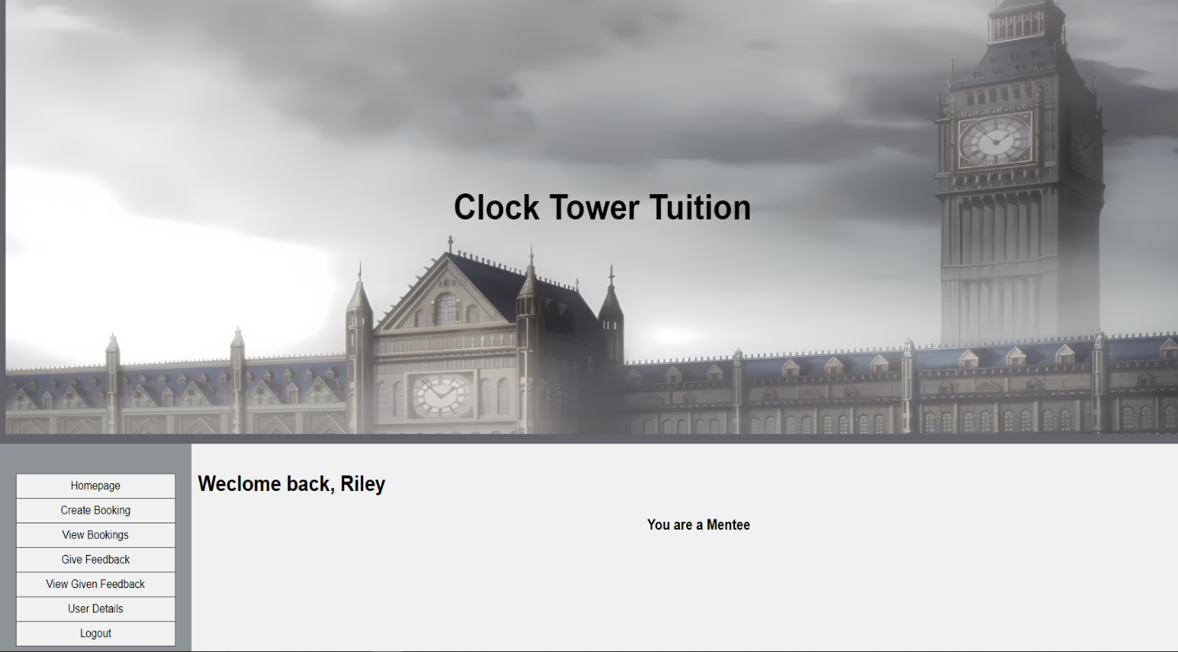

Dynamic homepage message and Menu

Menu is in Nav section, ensuring easy its always easy to access on any device

Dark text on light background for contrast, easier to read.

Simple instructions on all forms, placeholders where necessary.

Checkboxes when selecting fixed items for simplicty.

Repetitive design for improved learnability.

## PHP, HTML, & CSS

### connect.php

<?php

//0 = Not logged in

//1 = Logged in

//Main check data and retrieve data script

if (isset($_SESSION["LoggedIn"])) {

if ($_SESSION["LoggedIn"] == 0 ) { //If User isn't logged in

//echo"Not logged in!";

} elseif ($_SESSION["LoggedIn"] == 1 ) {

// fName Functions

if (isset($_SESSION["fName"])) {

if (!$_SESSION["fName"] == "" ) {

//echo"Logged in and name is set!".$_SESSION["LoggedIn"]." //";

}

} elseif (!isset($_SESSION["fName"])) {

$_SESSION["fName"] = "";

//echo "Session fName in is now set (to Blank) //";

}

}

//IF Var isn't set

} elseif (!isset($_SESSION["LoggedIn"])) {

$_SESSION["LoggedIn"] = 0;

echo '<script type="text/javascript"> window.location = "index.php" </script>';

}

//DB Connect

$servername = "localhost";

$dBUsername = "rhamp14";

$dBPassword = "Prussia.4";

$dBName = "rhamp14_tutoring";

$conn = mysqli_connect($servername, $dBUsername, $dBPassword, $dBName);

if(!$conn) {

die ("connection failed: ".mysqli_connect_error());

}

else {

//echo "Connection Successful";

}

?>

### header.php

<!DOCTYPE html>

<html lang="en">

<head>

<title>Clock Tower Tuition</title>

<!--Stop page caching locally to fix issue with IPT Online-->

<meta HTTP-EQUIV="Pragma" CONTENT="no-cache">

<meta charset="utf-8">

<meta name="viewport" content="width=device-width, initial-scale=1">

<!--If you change the CSS file and page is not reflecting changes try changing the version number below on the

css file eg. style.css?ver=1.1 -->

<link rel="stylesheet" href="style.css?ver=1.46">

</head>

<body>

<div id="page-container">

<div id="content-wrap">

<!-- all other page content -->

<!--Header section-->

<header>

<div class="con1">

<img src="logo.png" alt="Logo">

<div class="center1"><h5>Clock Tower Tuition</h5></div>

</div>

</header>

### nav.php

<!--Section section-->

<section>

<!--Nav section-->

<nav>

<ul>

<li><a href="index.php">Homepage</a></li>

<?php

if (isset($_SESSION["LoggedIn"])) {

if ($_SESSION["LoggedIn"]==0) {

echo'<li><a href="login.php">Login</a></li>';

echo'<li><a href="register.php">Register</a></li>';

} elseif ($_SESSION["LoggedIn"]==1) {

if ($_SESSION['lvlID']==1) {

echo'<li><a href="booking.php">Create Booking</a></li>';

echo'<li><a href="viewBookings.php">View Bookings</a></li>';

echo'<li><a href="giveFeedback.php">Give Feedback</a></li>';

echo'<li><a href="viewFeedback.php">View Given Feedback</a></li>';

echo'<li><a href="userDetails.php">User Details</a></li>';

echo'<li><a href="kill.php">Logout</a></li>';

} elseif ($_SESSION['lvlID']==2) {

echo'<li><a href="viewBookings.php">View Bookings</a></li>';

echo'<li><a href="openSessions.php">Open Sessions</a></li>';

echo'<li><a href="mentorSubjects.php">Select Subjects</a></li>';

echo'<li><a href="viewFeedback.php">View Feedback</a></li>';

echo'<li><a href="userDetails.php">User Details</a></li>';

echo'<li><a href="kill.php">Logout</a></li>';

} elseif ($_SESSION['lvlID']==3) {

echo'<li><a href=".php">Super Admin Mode)</a></li>';

echo'<li><a href="viewFeedback.php">View All Feedback</a></li>';

echo'<li><a href="userDetails.php">User Details</a></li>';

echo'<li><a href="registerAdmin.php">Supervisor Register</a></li>';

echo'<li><a href="kill.php">Logout</a></li>';

} else {

echo'<li><h1>Something is broken!</h1></li>';

}

}

} else {

echo'<li><h1>Please refresh the page!</h1></li>';

}

?>

</ul>

</nav>

### footer.php

<!--Footer section-->

<footer id="footer">

<p>© Riley Hampson 2023</p>

</footer>

Separating the Connect, header, Nav, and footer page enables easy editing without having to go edit multiple pages.

### index.php

<?php

session_start();

include 'header.php';

include 'nav.php';

require 'connect.php';

?>

<!--Article section-->

<article>

<?php

if ($_SESSION["LoggedIn"]==0) {

echo"<h1>Welcome to the Clock Tower Tuition Website!</h1>";

echo"<h2>Please register an account or login</h2>";

} elseif ($_SESSION["LoggedIn"]==1) {

echo"<h1>Weclome back, ".$_SESSION['fName']."</h1>";

if ($_SESSION['lvlID']==1) {

echo"<h2>You are a Mentee</h2>";

} elseif ($_SESSION['lvlID']==2) {

echo"<h2>You are a Mentor</h2>";

} elseif ($_SESSION['lvlID']==3) {

echo"<h2>You are a Supervisor</h2>";

} else {

echo"<h2>You are a God, apparently, cos something is broken and you have surpassed the highest of admins!</h2>";

}

} else {

echo"<h1>Welcome to the Clock Tower Tuition Website!</h1>";

}

?>

<div class="gap1"></div>

</article>

</section>

</div>

<?php

include 'footer.php';

?>

</div>

</body>

</html>

### openSessions.php

<?php

session_start();

include 'header2.php';

include 'nav.php';

require 'connect.php';

//Assign Vars

$userID = $_SESSION['userID'];

$term = 4; //Term & Year Set in var for when an actual menu to select them is chosen

$year = 2023;

//SQL Query

$sql = "SELECT week, booked FROM Sessions WHERE year = '".$year."' AND term = '".$term."' AND mentorID = '".$userID."' ";

$result = mysqli_query($conn, $sql);

//Assign to array

$selectedWeeks = array();

$booked = array();

while ($row = mysqli_fetch_assoc($result)) {

$selectedWeeks[] = $row['week'];

$booked[$row['week']] = $row['booked'];

}

?>

<!--Article section-->

<article >

<h1>Please select the weeks you can tutor in Term 4 2023!</h1><br><br>

<form name="submit" method="post" action="openSessions.php" class="center"> <!--Main Form-->

<input type="checkbox" id="1" name="weekCB[]" value="1" <?php if (in_array(1, $selectedWeeks) && isset($booked[1]) && $booked[1] == 'N') echo 'checked'; if (isset($booked[1]) && $booked[1] == 'Y') echo 'disabled'; ?>>

<label for="1">Week 1 <?php if (isset($booked[1]) && $booked[1] == 'Y') echo '(This session has been booked, you CANNOT unselect it.)'; ?> </label><br>

<input type="checkbox" id="2" name="weekCB[]" value="2" <?php if (in_array(2, $selectedWeeks) && isset($booked[2]) && $booked[2] == 'N') echo 'checked'; if (isset($booked[2]) && $booked[2] == 'Y') echo 'disabled'; ?>>

<label for="2">Week 2 <?php if (isset($booked[2]) && $booked[2] == 'Y') echo '(This session has been booked, you CANNOT unselect it.)'; ?> </label><br>

**Checkbox 3-10 have been deleted to conserve space**

<input name="submit" type="submit" value="Submit" class="btn">

</form>

<?php

if (isset($_POST['submit'])) {

$weekCB = $_POST['weekCB'] ;

$userID = $_SESSION['userID'];

//SQL Query

$sql = "SELECT week FROM Sessions WHERE year = '".$year."' AND term = '".$term."' AND mentorID = '".$userID."'";

$result = mysqli_query($conn, $sql);

//Assign to array

$selectedWeeks = array();

while ($row = mysqli_fetch_assoc($result)) {

$selectedWeeks[] = $row['week'];

}

// Check if a week is selected or unselected

foreach ($selectedWeeks as $selectedWeek) {

if (in_array($selectedWeek, $weekCB)) { //Subject the same, continue

continue;

} else { // Week is unselected, remove it from the database

$deleteSql = "DELETE FROM Sessions WHERE year = '".$year."' AND term = '".$term."' AND mentorID = '".$userID."' AND week = '".$selectedWeek."'";

mysqli_query($conn, $deleteSql);

echo '<script type="text/javascript">window.location = "openSessions.php"</script>';

}

}

// Insert newly selected weeks into the database

foreach ($weekCB as $week) {

if (!in_array($week, $selectedWeeks)) {

$insertSql = "INSERT INTO Sessions (mentorID, year, term, week, booked) VALUES ('".$userID."', '".$year."', '".$term."', '".$week."', 'N')";

mysqli_query($conn, $insertSql);

echo '<script type="text/javascript">window.location = "openSessions.php"</script>';

}

}

echo "<h2>Available weeks to tutor updated!</h2>";

}

?>

</article>

</section>

</div>

<?php

include 'footer.php';

?>

</div>

</body>

</html>

openSessions.php uses arrays and for each loops to convert checkbox inputs into sql data. This script creates sessions, then can delete them if they HAVEN’T been booked already,

### mentorSubjects.php

<?php

session_start();

include 'header2.php';

include 'nav.php';

require 'connect.php';

//Assign Vars

$userID = $_SESSION['userID'];

//SQL Query

$sql = "SELECT subjectID FROM MentorSubjects WHERE userID = '".$userID."'";

$result = mysqli_query($conn, $sql);

//Assign to array

$selectedSubjects = array();

while ($row = mysqli_fetch_assoc($result)) {

$selectedSubjects[] = $row['subjectID'];

}

?>

<!--Article section-->

<article >

<h1>Please select the subjects you can tutor!</h1><br><br>

<form name="submit" method="post" action="mentorSubjects.php" class="center"> <!--Main Form-->

<input type="checkbox" id="1" name="subjectCB[]" value="1" <?php if (in_array(1, $selectedSubjects)) echo 'checked'; ?>>

<label for="1">Digital Solutions</label><br>

**Deleted 1-5 due to code being the same to conserve space **

<input type="checkbox" id="6" name="subjectCB[]" value="6" <?php if (in_array(6, $selectedSubjects)) echo 'checked'; ?>>

<label for="6">Chemistry</label><br><br><br>

<input name="submit" type="submit" value="Submit" class="btn">

</form>

<?php

if (isset($_POST['submit'])) {

$subjectCB = $_POST['subjectCB'] ;

$userID = $_SESSION['userID'];

//SQL Query

$sql = "SELECT subjectID FROM MentorSubjects WHERE userID = '".$userID."'";

$result = mysqli_query($conn, $sql);

//Assign to array

$selectedSubjects = array();

while ($row = mysqli_fetch_assoc($result)) {

$selectedSubjects[] = $row['subjectID'];

}

// Check if a subject is selected or unselected

foreach ($selectedSubjects as $selectedSubject) {

if (in_array($selectedSubject, $subjectCB)) { //Subject the same, continue

continue;

} else { // Subject is unselected, remove it from the database

$deleteSql = "DELETE FROM MentorSubjects WHERE userID = '".$userID."' AND subjectID = '".$selectedSubject."'";

mysqli_query($conn, $deleteSql);

echo '<script type="text/javascript">window.location = "mentorSubjects.php"</script>';

}

}

// Insert newly selected subjects into the database

foreach ($subjectCB as $subjectID) {

if (!in_array($subjectID, $selectedSubjects)) {

$insertSql = "INSERT INTO MentorSubjects (userID, subjectID) VALUES ('".$userID."', '".$subjectID."')";

mysqli_query($conn, $insertSql);

echo '<script type="text/javascript">window.location = "mentorSubjects.php"</script>';

}

}

echo "<h2>Subjects Selections Updated</h2>";

}

?>

</article>

</section>

</div>

<?php

include 'footer.php';

?>

</div>

</body>

</html>

mentorSubjects.php allowes mentors to select which subjects they want to tutor. Similar to openSessions.php, this uses arrays to input checkboxes into the sql database.

### booking.php

<?php

session_start();

include 'header2.php';

include 'nav.php';

require 'connect.php';

?>

<!--Article section-->

<article >

<h1>Please select the Subject and Week (Term 4 2023) </h1><br><br>

<form name="submit" method="post" action="booking2.php">

<?php //Drop Down List

$sql = "SELECT DISTINCT subjectID, subjectName FROM Subjects"; //SQL Query

$result = mysqli_query($conn, $sql);

echo "Subject: ";

echo "<select name='subjectID'>";

while ($row = mysqli_fetch_assoc($result)){

$subjectID = $row['subjectID'];

$subjectName = $row['subjectName'];

echo '<option value="'.$subjectID.'">'.$subjectName.'</option>';

}

echo "</select>";

?>

<br><br>

Week:

<select name="week">

<option value="1"> Week 1</option>

**2-9 Removed for Space**

<option value="10"> Week 10</option>

</select><br><br>

<input name="submit" type="submit" value="Submit"><br/><br/>

</form><br><br>

</article>

</section>

</div>

<?php

include 'footer.php';

?>

</div>

</body>

</html>

### booking2.php

<?php

session_start();

include 'header2.php';

include 'nav.php';

require 'connect.php';

?>

<!--Article section-->

<article >

<h1>Please select the subject you would like tutoring for! </h1><br><br>

<?php

if (isset($_POST['submit'])) {

$userID=$_SESSION["userID"]; //Assign User Vars

$subjectID = $_POST['subjectID']; //Assign Posts

$week = $_POST['week'];

//SQL

$sql = "SELECT s.sessionID, u.fName, u.sName, u.email, subj.subjectName

FROM Sessions s

INNER JOIN Users u ON s.mentorID = u.userID

INNER JOIN MentorSubjects ms ON u.userID = ms.userID

INNER JOIN Subjects subj ON ms.subjectID = subj.subjectID

WHERE s.booked = 'N' AND subj.subjectID = '".$subjectID."' AND s.week = '".$week."' ";

$result = mysqli_query($conn, $sql);

echo"Sub: ".$subjectID." ";

echo"Week: ".$week." ";

//Print Table

echo "<br>";

echo "<table border='1'>";

echo "<tr><th>SessionID</th><th>Mentor Name</th><th>Mentor Email</th><th>Subject</th><th>Button</th></tr>"; //Table titles

while($row = mysqli_fetch_assoc($result)){

echo "<tr>

<td>{$row['sessionID']}</td>

<td>{$row['fName']} {$row['sName']}</td>

<td>{$row['email']}</td>

<td>{$row['subjectName']}</td>

<td>

<form method='post' action='bookSession.php'>

<input type='hidden' name='sessionID' value='".$row['sessionID']."'>

<input type='hidden' name='subjectID' value='".$subjectID."'>

<input type='hidden' name='menteeID' value='".$userID."'>

<button type='book' name='book'>Book</button>

</form>

</td>

</tr>";

}

echo "</table>";

}

?>

</article>

</section>

</div>

<?php

include 'footer.php';

?>

</div>

</body>

</html>

booking.php inputs which subject and week the mentee is looking for.

booking2.php displays open sessions with mentors that tutor the subject the mentee is after along with a button to book the session.

# Evaluation

## Criteria

|  |  |
| --- | --- |
| **Prescribed:** | Yes/No |
| By the due date, 8:30 am Monday 2nd October 2023:   * Designed and implemented an effective normalised relational database to store data and user inputs. * Students can register as a mentee or mentor. (Supervisor accounts are preset to protect system safety and data integrity) * Mentees can find tutoring sessions for their subject then book it and provide feedback. * Mentors can select subjects to tutor and open sessions when they are available, and view provided feedback. * Both Mentees and Mentors can view their future sessions * Supervisors can view all open and booked sessions as well as reports for the number of sessions booked for subject/ year level combinations. * Use consistent variables and file naming conventions. * Have a learnable user interface (UI) that is effective and accessible while maintaining an enjoyable user experience (UX) | Y  Y  Almost – Feedback WIP  Y  Y  WIP  Y  Y |
| **Self-determined:** | Yes/ No |
| By before the due date, on Friday 29th September 2023:   * (Ensure all prescribed criteria are met.) * (Build a prototype login and register system that assists the criteria above.) * Ensure all code is commented, indented, and appropriately used whitespace on all pages. * Effectively use HTML and PHP to create a consistent website structure. * Effectively use CSS to create a consistent website design and user experience UX. * Appropriately use HTML and CSS to have a consistent and learnable UI and adhere to design principles. * Use selection and iteration in PHP to produce efficient code. * Implement measures to protect data integrity. * Use PHP to interpret and display data retrieved from the SQL database. | Almost  Y  Y (More commenting needed)  Y  Y  Y  Y  Y  Y |

## Recommendations

This version of the web application is a WIP prototype so there are many features that were not implemented due to time constraints.

Most of the prescribed criteria have been met, although the feedback system is still in development, with all users being able to view feedback, but the mentees can’t actually provide any.

Currently, the term and year are fixed variables, Admins should have the ability to change these, therefore automatically changing the titles and webpages accordingly, this feature is essential if this system were to be deployed in actual use.

Currently, there is no way for mentees to cancel a session they have booked, although this is very close to completion.

A page listing the time and day of the tutoring session each week was supposed to be built first but was skipped in favour of completing the base application.

Most importantly the passwords **aren’t** encrypted and are plain text in the database, this is obviously the first fix if this system were to be deployed.

## Desk Check

|  |  |  |  |
| --- | --- | --- | --- |
| Action | Expected outcome | Actual outcome | Recommendation |
| Login | Assigns variables & moves to the index page | (Worked) |  |
| Create booking | Click book & it books the session | (Worked) |  |

## Prescribed criteria

For this task, an interactive web application was produced to create a vertical academic tutoring process by going through the problem-solving phases of explore, develop, generate, and evaluate/ refine. During the explore phase a mind map was produced to lay out the problem in a way that is easier to comprehend. During the develop phase multiple dataflow diagrams were created to separate and work out the movement of data throughout the web application. During the design phase, the database was constructed with the assistance of an entity relationship diagram which displayed the logical relationship between the sections of the database. Wireframes were produced to scaffold the design process of the website ensuring a good UI and UX. Algorithms were also produced to decompose difficult sections of code, making them easier to complete. All of these resources mentioned earlier assisted throughout the generate phase, guiding the production of this web application. All of the prescribed criteria have been met or are within arm’s reach due to extensive work on the basis of the application, making further development easy.

## Self-determined criteria

All of the code in the task was or was almost appropriately commented, having correct indentation and correct whitespace. HTML and PHP were used effectively to create a consistent website structure. CSS was effectively used to enhance and ensure a great UX. HTML and CSS were used appropriately to have a learnable UI that adhered to design principles. Measures such as dropdown boxes were implemented to assist in protecting data integrity. Selection and iteration was used in PHP to produce efficient code. Lastly, PHP was used to interpret and display data retrieved from the databases.

## Impacts – Personal, Social and Economic

This web application will greatly and positively impact all of these categories. Enabling students’ easier access to tutoring through older students instead of through paid services positively impacts lower-income students who wish to excel in their studies. Connecting more students impacts them socially as they will be able to connect with people, they may have never had the chance to interact with before. The social and economic benefits should have a personal benefit on the students, as they don’t have to pay for tutoring services, and can network with others while personally gaining in their studies, allowing them to succeed more in life.

# Bibliography

ipto.com.au. (n.d.). Digital Solutions Online. [online] Available at: <https://ipto.com.au/>.

W3Schools (2023). W3Schools Online Web Tutorials. [online] W3schools.com. Available at: <https://www.w3schools.com/>.